PROJECT REPORT TEMPLATE ON POPULATION FORECASTING ANALYSIS

1 INTRODUCTION

* 1. OVERVIEW

A population projection gives a picture of what the future size and structure of the population by sex and age might look like.

It is based on knowledge of the past trends, and, for the future, on assumptions made for three components: fertility, mortality and migration

* 1. PURPOSE

The projections serve as a basis for long-term thinking, particularly in terms of collective development. They make it available to analyse population trends if the assumptions are true, but are not forecasts. Individual behavior, certain public policy actions, scientific progress or unforeseen events (weather events, epidemics) in the coming years may have a lasting effect and significantly influence trends, which the projections do not take into account.

1. PROBLEM DEFINITION & DESIGN THINKING
   1. EMPATHY MAP

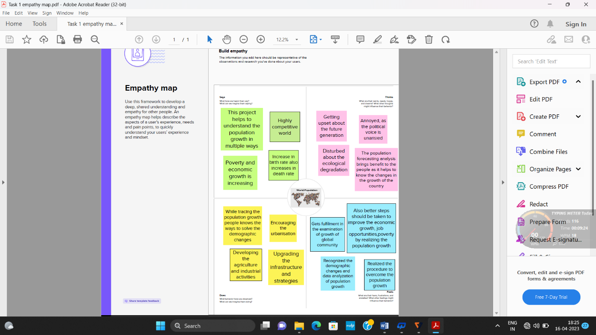

* 1. IDEATION AND BRAINSTORMING MAP

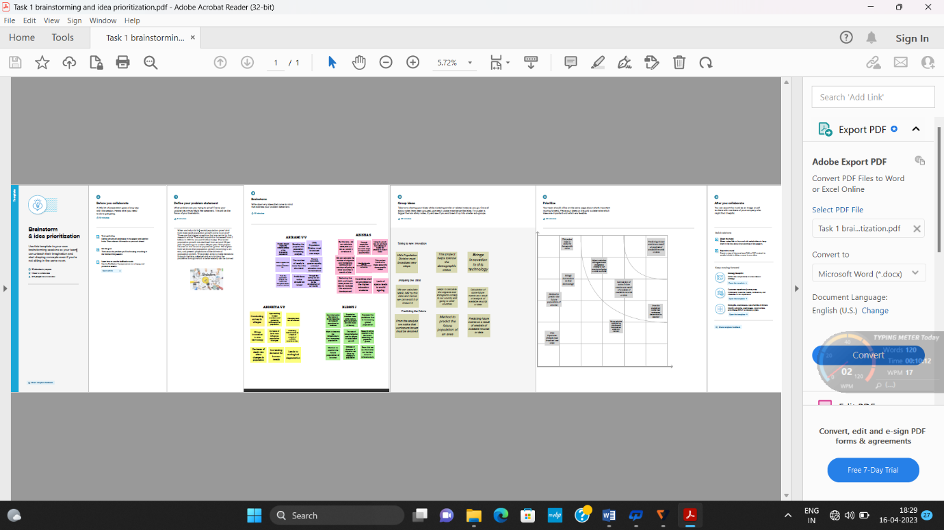

1. RESULT

3.1 DASHBOARD ON POPULATION ANALYSIS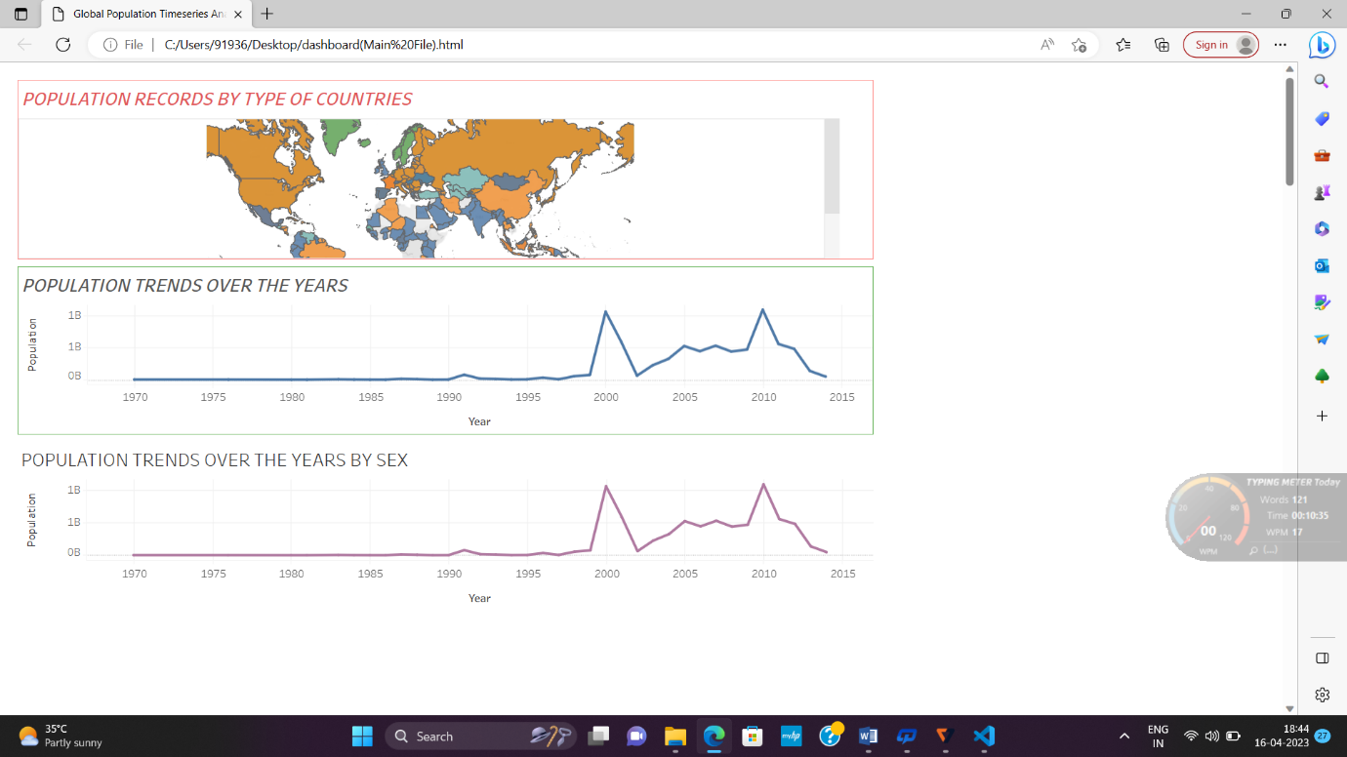

3.2 STORY ON POPULATION ANALYSIS

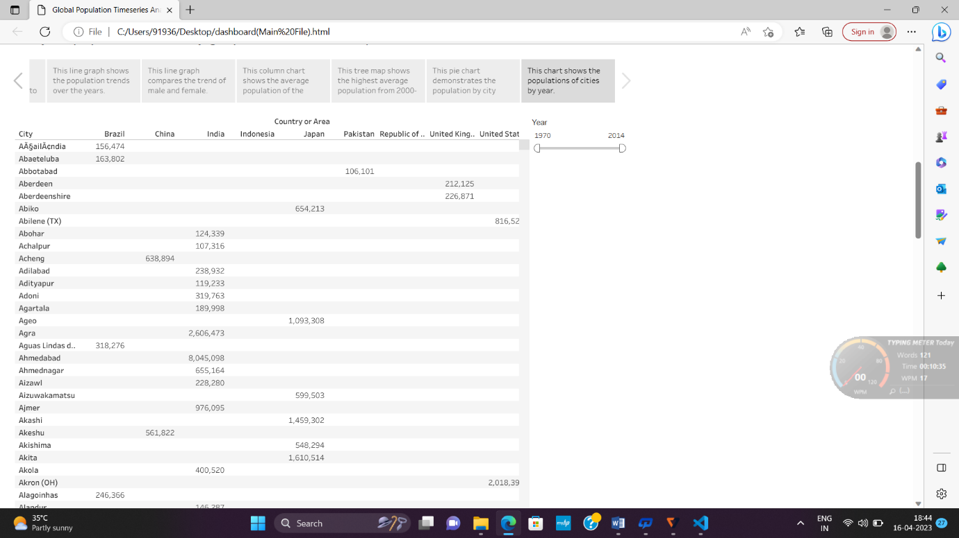

1. ADVANTAGES AND DISADVANTAGES

ADVANTAGES

* Calculation or prediction of some future events as a result of study and analysis of available records or data is the population forecasting
* To design various infrastructures facilities like water supply scheme, sewage disposal unit, the basic record of current population and future population is must
* Therefore an estimate of future population is necessary for designing the facilities.

DISADVANTAGES

* Population projections are trend based. They are, therefore, not policy based forecasts of what the government expects to happen. Many social and economic factors influence population change, including policies adopted by both central and local government. The relationships between the various factors are complex and largely unknown.
* The reliability of projections decreases over time, and projections tend to be less reliable in periods of rapid change. Projections for areas with small population tend to be less reliable than those for areas with large populations.
* Population projections, like some other types of projections, may indicate that existing trends and policies are likely to lead to outcomes which are judged undesirable. If new policies are then introduced, they may result in the original projections not being realized.

1. APPLICATIONS

The population forecasting methods require the values of present and past population records to undergo the calculation. The local census records of a particular area provide the value present and past populations. Population projection is important since it helps people i.e. government, researchers, make decisions about the future.

1. CONCLUSION

This project helps to know the demographic status of the population. Through this project we come to know the opinion of people about population. Population forecasting analysis project helps to have a good interactive collaboration with team members which help us to create empathy map depending their ideas.

1. FUTURE SCOPE

It provide job opportunities for future generations. It paves the way for economic growth along with help environment. It place an important role in technology development.